**Brief description of the developed program interface and functionality of the device for controlling the microclimate of the phytochamber**

**1. General structure of the complex**

This complex device is designed to control the microclimate of a compact phytochamber for growing early-ripening crops such as microgreens or lettuce. The device has components for data input/output, actuators and sensors. The entire system is powered by an external 5 V power source. An important feature of this device is the connection of two controllers via digital pins through a voltage divider for data exchange using a digital serial port. The ESP32 controller is responsible for the main logic of the entire system, data output to the LCD display, switching from one mode to another, and the Arduino Mega controller is responsible for polling sensors and turning on/off the actuators of the system. Below, in Figure 1, is the wiring diagram of the device.

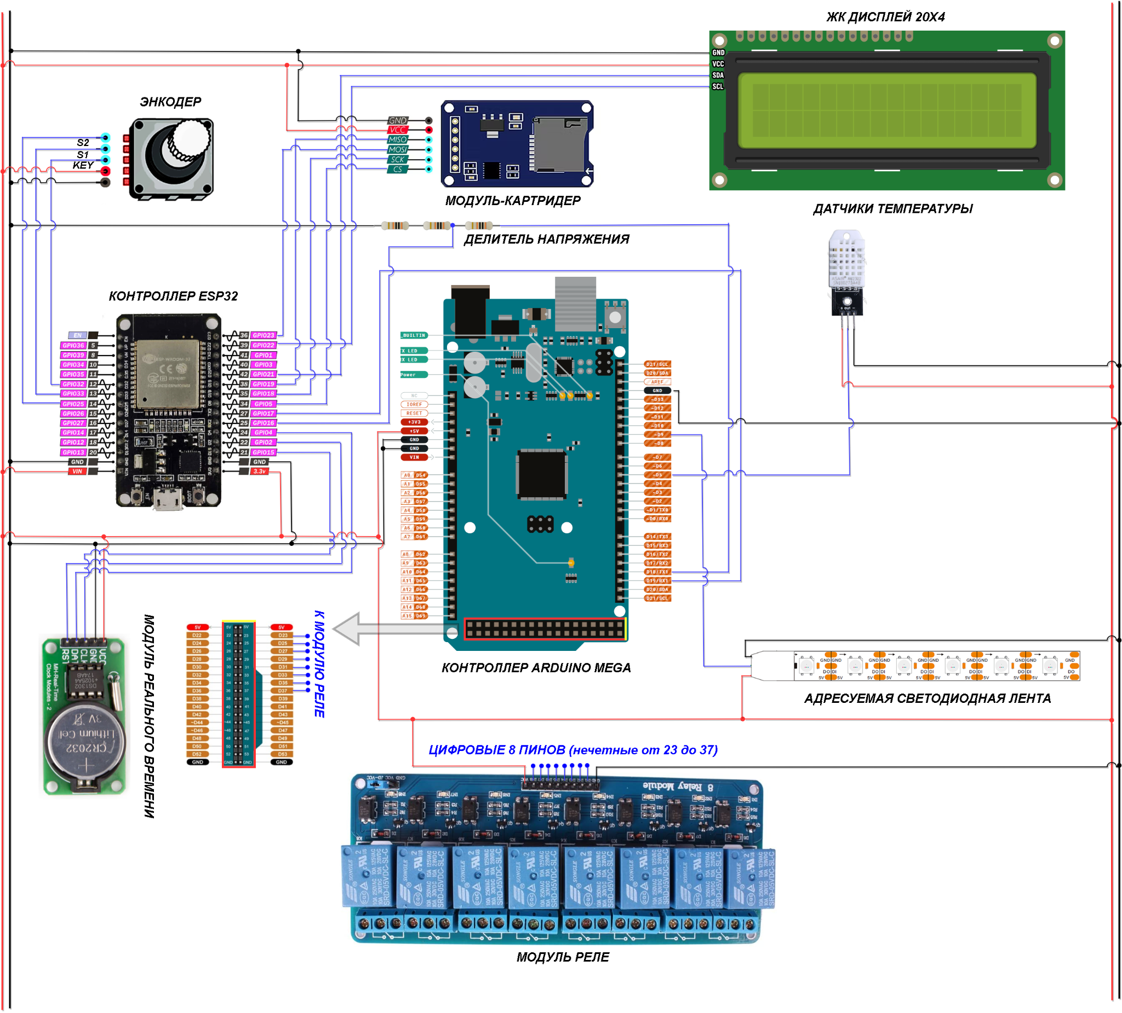

Figure 1. — Assembly diagram of the complex

As can be seen from the wiring diagram, this device consists of the following components: controller (ESP32), controller (Arduino Mega), air temperature and humidity sensor (DHT11), addressable LED strip (WS2812B), block of 8 relay modules (Jbtek 8), SD card reader module, real-time module (DS1302), rotation encoder (Bondar BBI-32), 20x4 LCD display with I2C interface. Below, in Figure 2, is an already assembled illustration of the device.

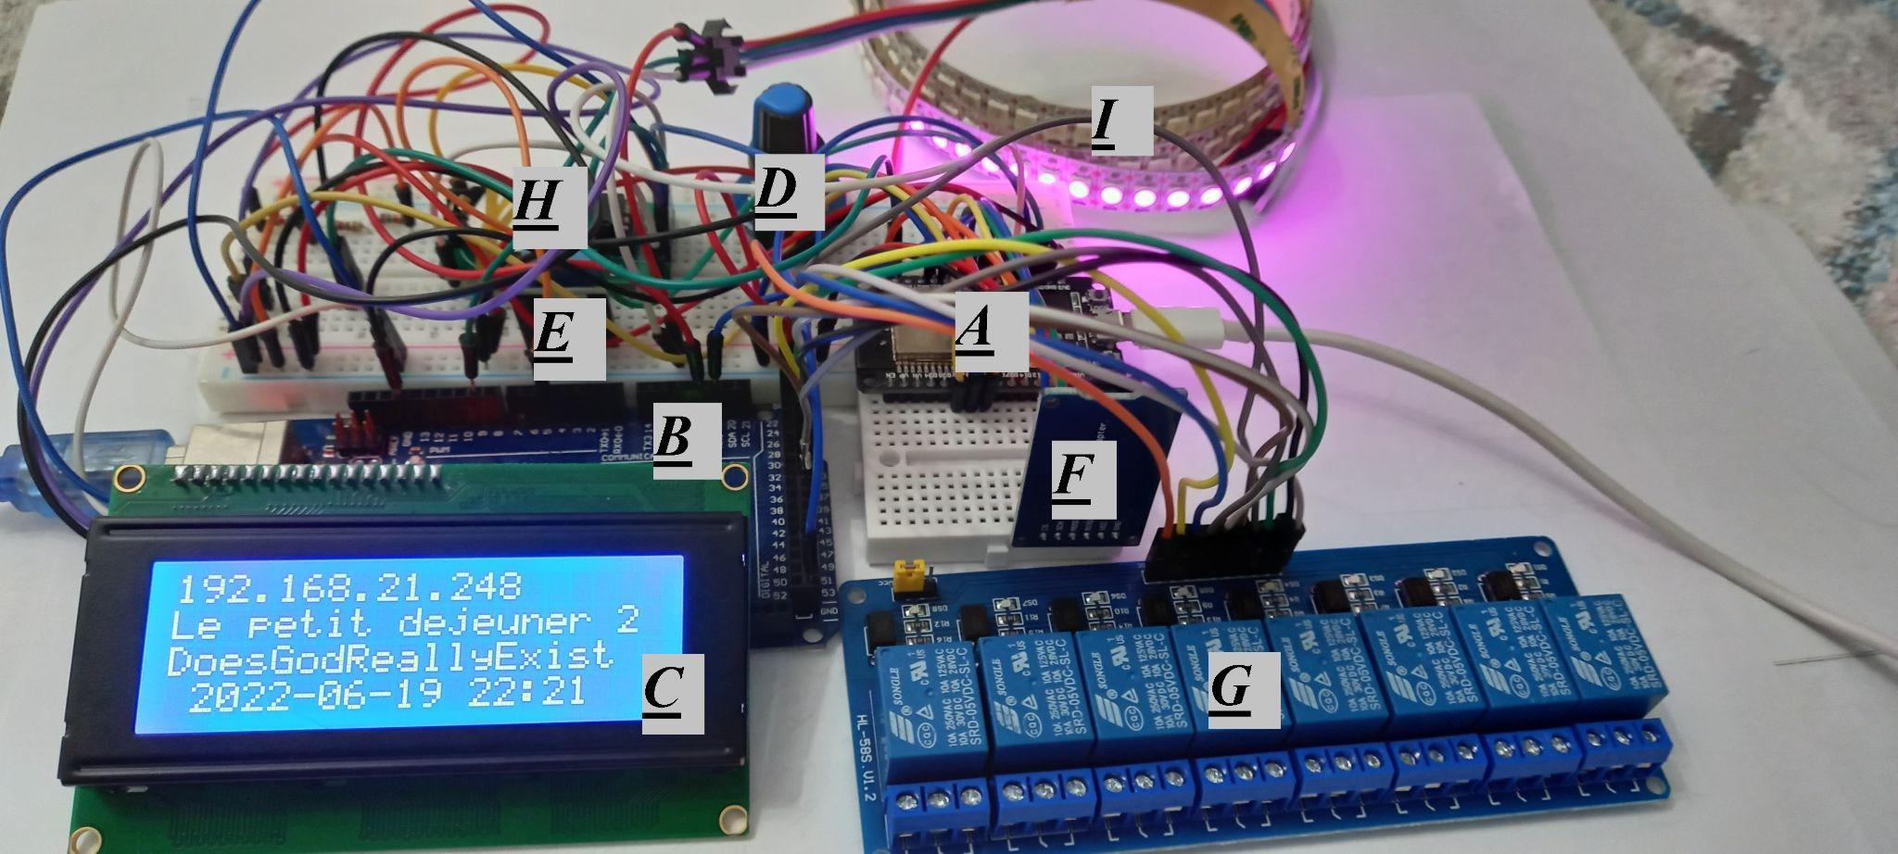

*A- controller (ESP32); B - controller (Arduino Mega); C - 20x4 LCD with I2C interface; D - rotation encoder (Bondar BBI-32); E - air temperature and humidity sensor (DHT11); F - SD card reader module; G - block of 8 relay modules (Jbtek 8); H - real-time module (DS1302); I - addressable LED strip (WS2812B);*

Figure 2. — Assembled model of the device

This device operates in two modes, namely web-oriented and manual. A detailed analysis of the features of operation in the above modes is discussed below.

The listing of programs loaded onto the controllers is provided in the links below.

ESP32:https://github.com/Yerlan999/SmartGreenHouse-KazATU/blob/main/Automatic_GreenHouse/Advanced_Combined_GUI/Advanced_Combined_GUI.ino

Arduino Mega:https://github.com/Yerlan999/SmartGreenHouse-KazATU/blob/main/Automatic_GreenHouse/Arduino_to_ESP32_date_exchange/Arduino_to_ESP32_date_exchange.ino

**2. Web-oriented mode of operation.**

This mode is designed to control the microclimate of the phytochamber by making changes to the system via a web page created on the ESP32 microcontroller. This controller allows you to connect to an available WiFi network and host (publish) web pages, as it has a built-in WiFi module.

When switched on, the device automatically searches for available WiFi networks or access points, the data of which has already been entered into the firmware of the program. The number of such known networks can be entered an unlimited number of times. The web page mode of operation (hereinafter referred to as the online mode of operation) is designed in such a way that when connected to one of the already known access points or WiFi networks, it displays the basic data of this network, such as: the IP address of the page where the web page is located, the network name and password. The bottom line of the LCD display displays the current date and time received from the device distributing the network. An example is shown in Figure 3 below. It is important to note that the IP address can only be used to access the web page when connected to the network specified on the bottom line.

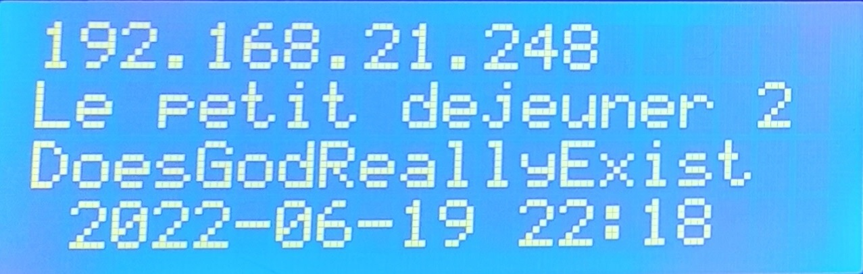

Figure 3. — Example of output data about the connected network.

When going to the IP address, the user will be greeted by a window for entering login data. This window requests the input data of the device. An example is shown in Figure 4. In this case, the input data is “micro” for the name and for the password.

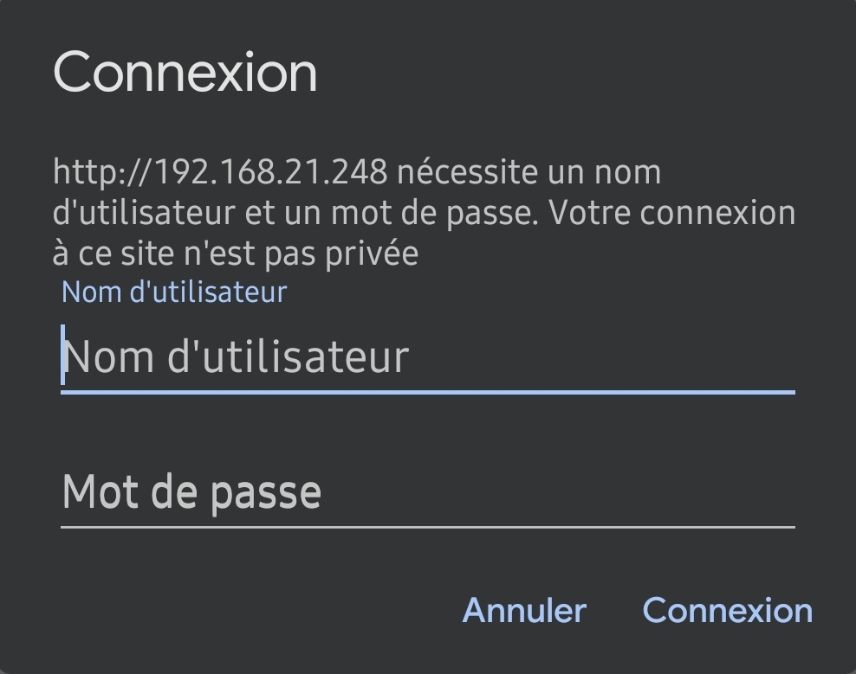

Figure 4. — Input data entry window.

After successful data validation, the user will be greeted by the following interface, shown in Figure 5. This interface consists of a section for displaying sensor values ​​and a section for monitoring the main system parameters.

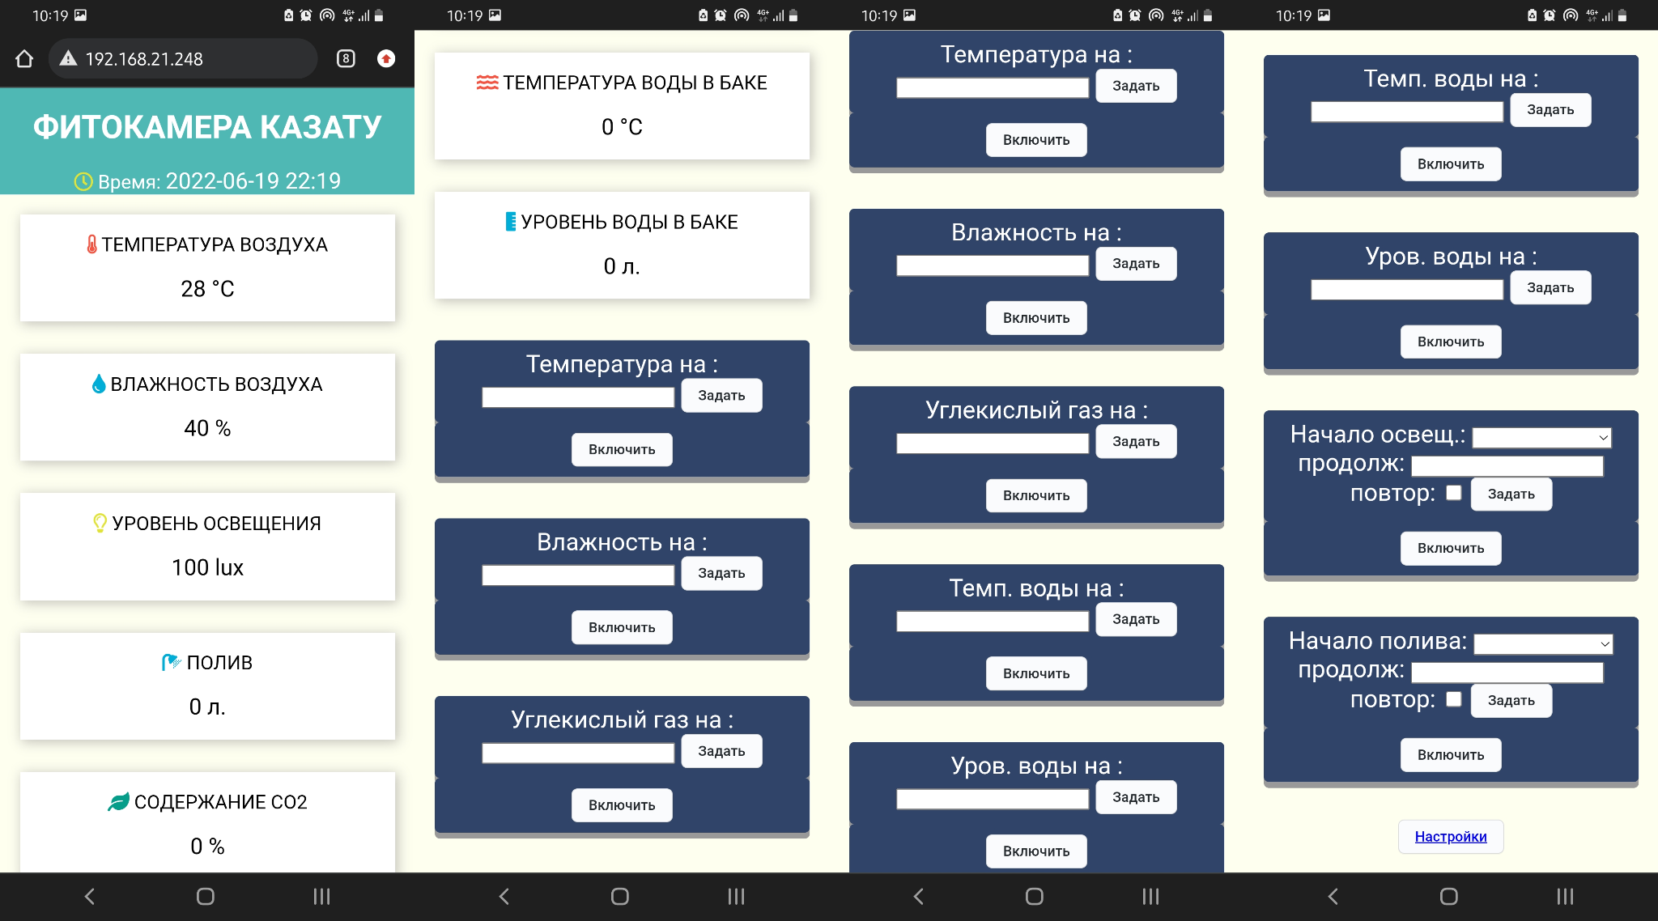

Figure 5. — Web interface of the program.

Below is a button for going to the settings section where you can adjust the value of the time interval for data exchange between controllers and the brightness of the LED strip. The illustration is shown in Figure 6.

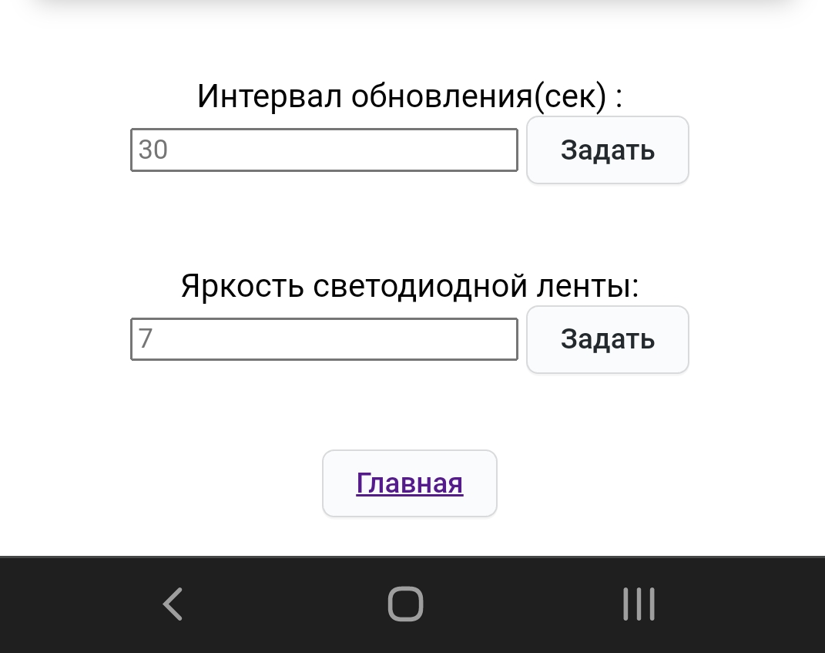

Figure 6. — Settings section

The system parameters are monitored by entering the required value in the cell of the control button and confirming by pressing the “Set” button. After that, in the section displaying the sensor values, the corresponding section will turn red, thereby confirming that the system value is being monitored. An example of this process is shown in Figure 7.

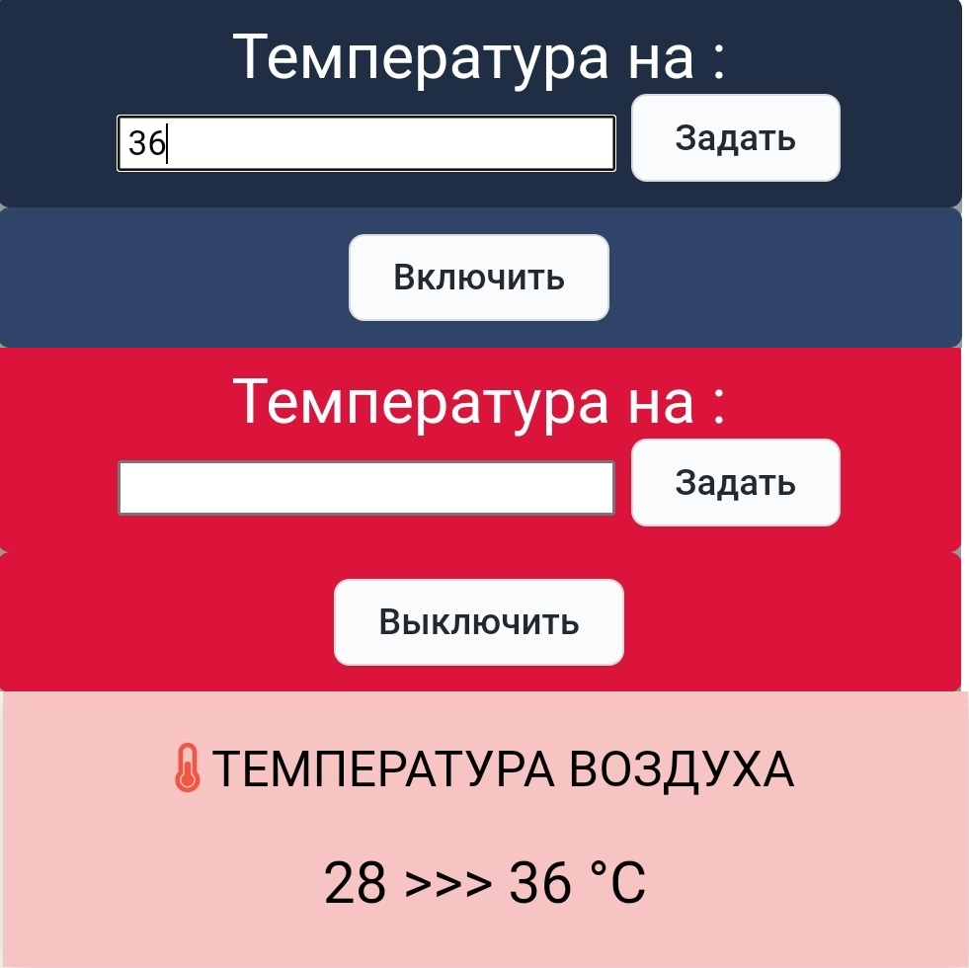

Figure 7. — Setting the air temperature system parameter

Also, this button can in normal mode turn on and off the executive organ of the system by means of an additional button “On” or “Off”. Other systems also function according to the logic described above, such as: air humidity, water level in the tank, carbon dioxide level, water temperature.

The systems for monitoring lighting and watering plants have a completely different functionality. The parameters of these systems are mainly controlled through time control, implemented in the form of two main modes. The first mode allows you to set the start time and duration of watering with the ability to set it to repeat every day. The second mode allows you to set the duration of watering and the duration of the pause. It is important to note that to switch the control button to the second mode, you must press the control button of the corresponding system twice. An example of control buttons is shown in Figure 8 below. A more detailed example is shown in Figure 9.

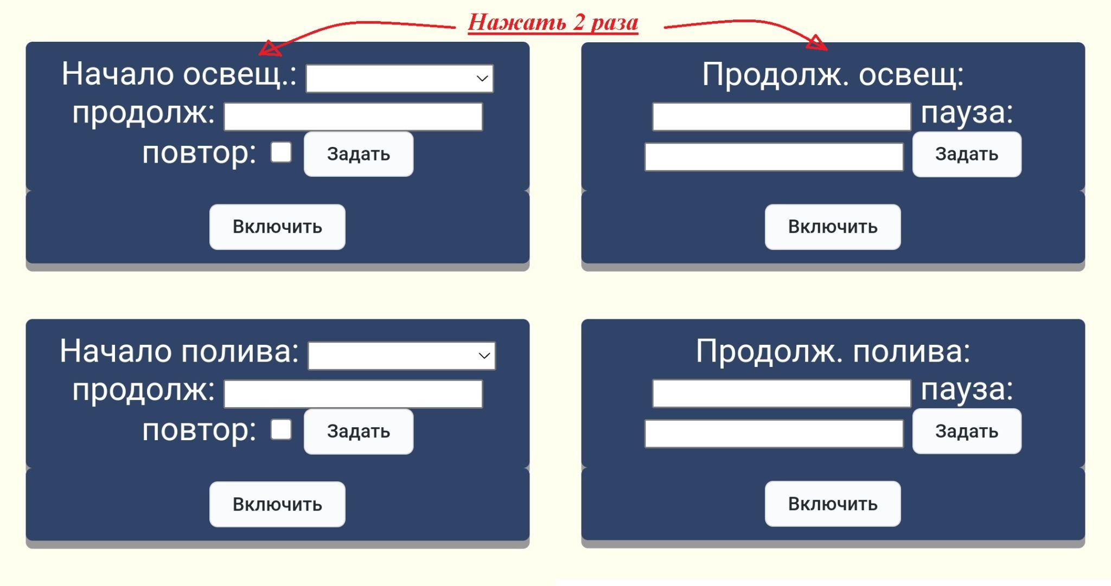

Figure 8. — Setting the parameters of irrigation and lighting systems.

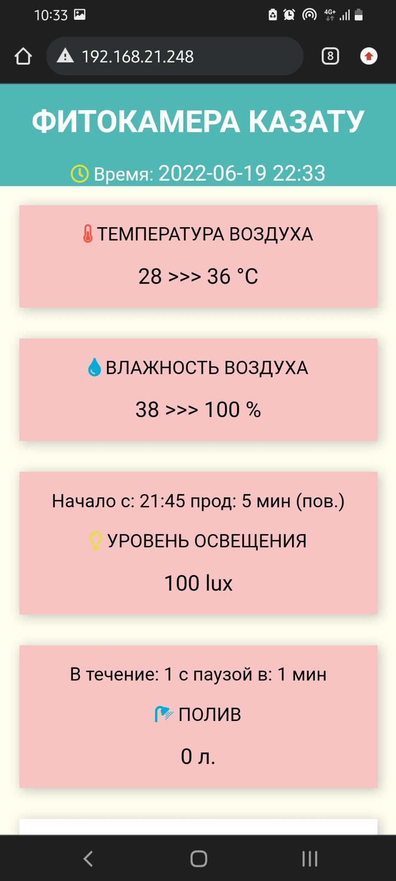

Figure 9. - An example of more complete control of systems.

This mode of operation automatically switches to manual mode when the WiFi network is lost, which will be described in detail below. Also, the online mode, with a certain frequency, assigned in the settings section, searches for known networks and access points, and when found, it returns to the web-oriented mode. The transition from one mode to another is performed without losing data and the main parameters of the systems specified by the user, since the connected SD card reader module records all system parameters and keeps track of the current values ​​​​from the sensors for their further analysis.

**3. Manual operation mode.**

The manual mode of operation is fully communicated with the online mode of operation and mirrors it. To control and enter data into the system, the user must rotate the encoder, which has several states. This encoder can be rotated in both directions, pressed, pressed and held, pressed and rotated in both directions. The general control logic is shown in Figure 10.

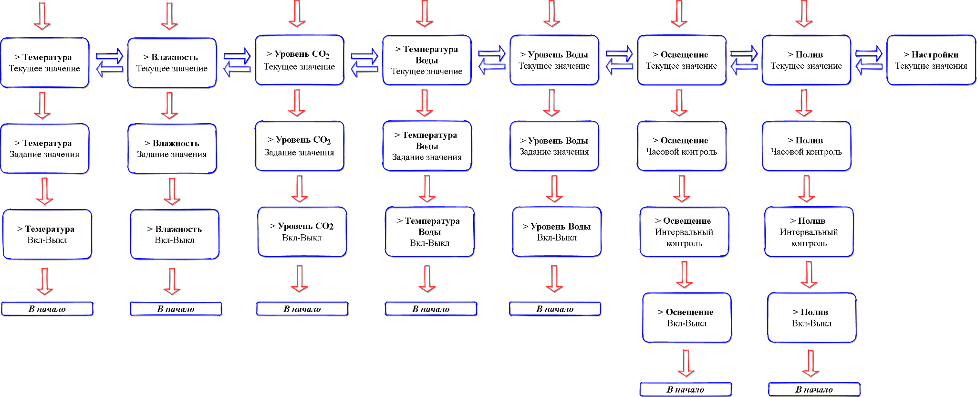

Figure 10. — Menu windows and manual mode control logic.

Red arrows - transition by pressing the encoder. Blue arrows - transition by pressing (holding) and rotating the encoder. These transitions between menus are performed only if the “>” pointer is set on the title of the corresponding mode. An example of this state is shown in Figure 11.

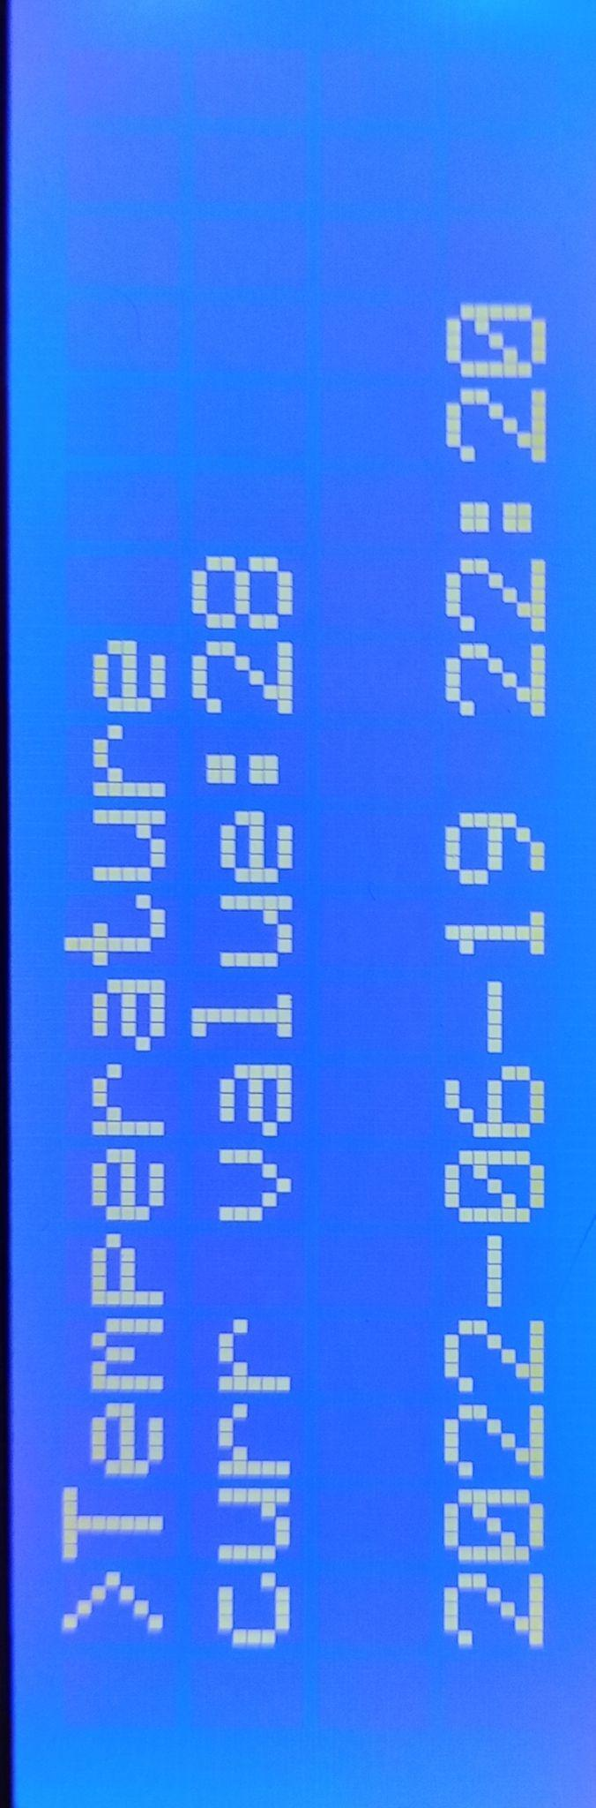

Figure 11. — An example of the correct position of the “>” pointer for switching between menu windows.

To make changes to the system parameters, it is necessary to go to the menu of interest to the user and point the pointer to the corresponding cell. Figure 12 shows an example of setting the time parameters of the irrigation system. This cell has a feature in that to enter hours and minutes, the user must press the encoder once and twice, respectively. That is, when the pointer “-” appears, hours are entered, and when “=” appears, minutes of the system time. All other cells of all systems require only one click to make a change.

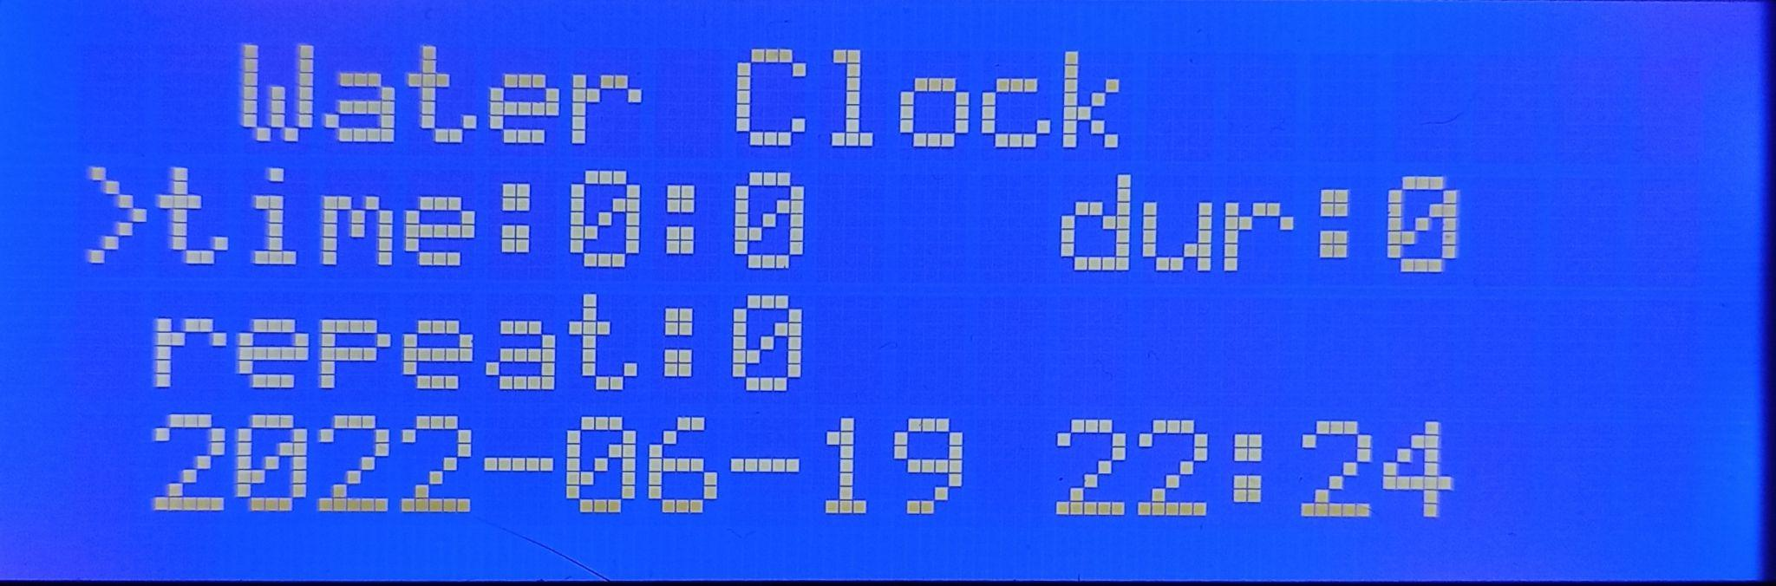

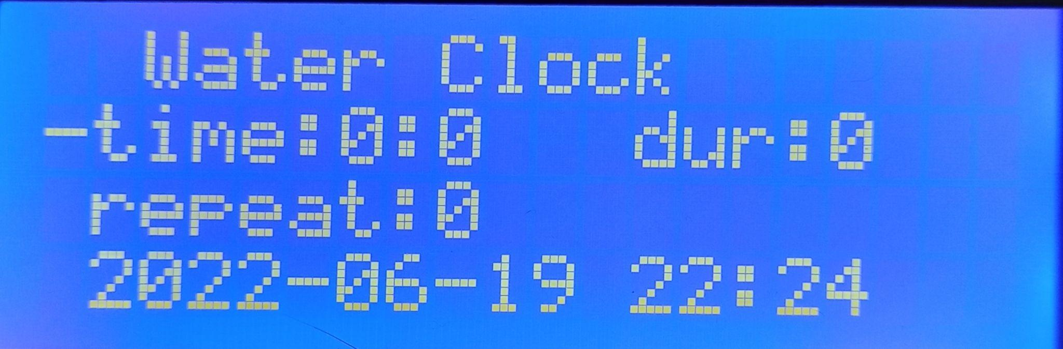

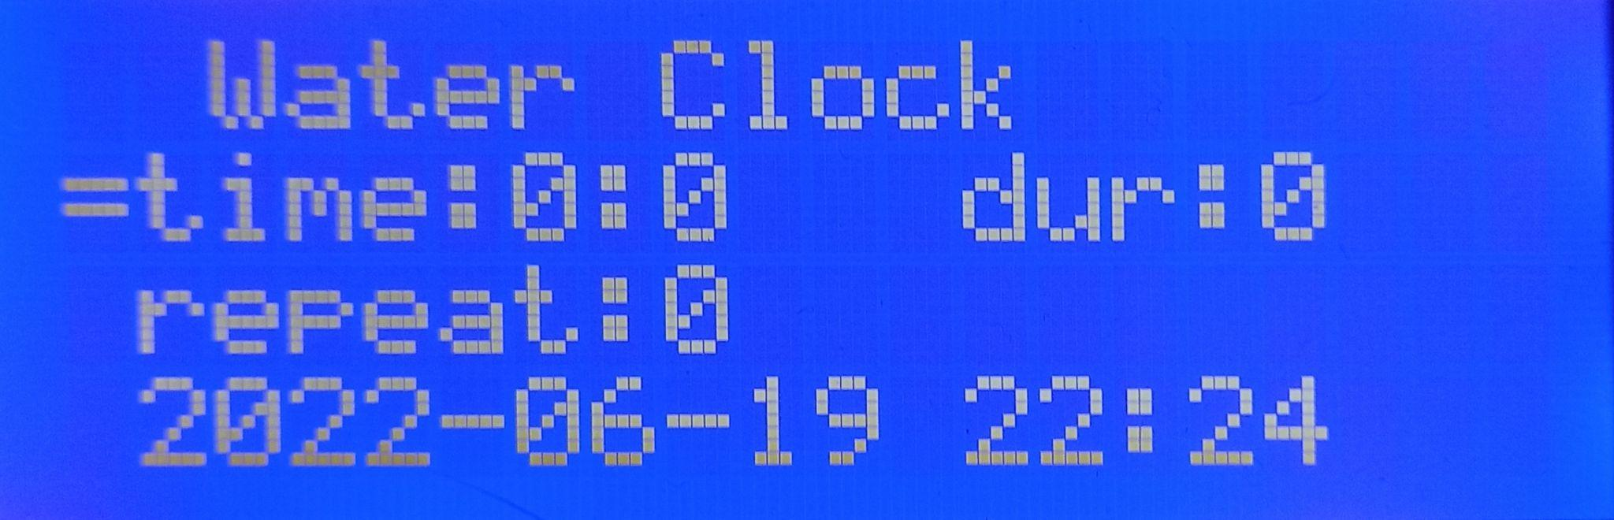

Figure 12. - An example of the correct placement of the “>” pointer to make changes to the irrigation system.

The DS1302 real time module is responsible for displaying the current time in manual mode. An example of already set values ​​for the lighting system is illustrated in Figure 13 below.

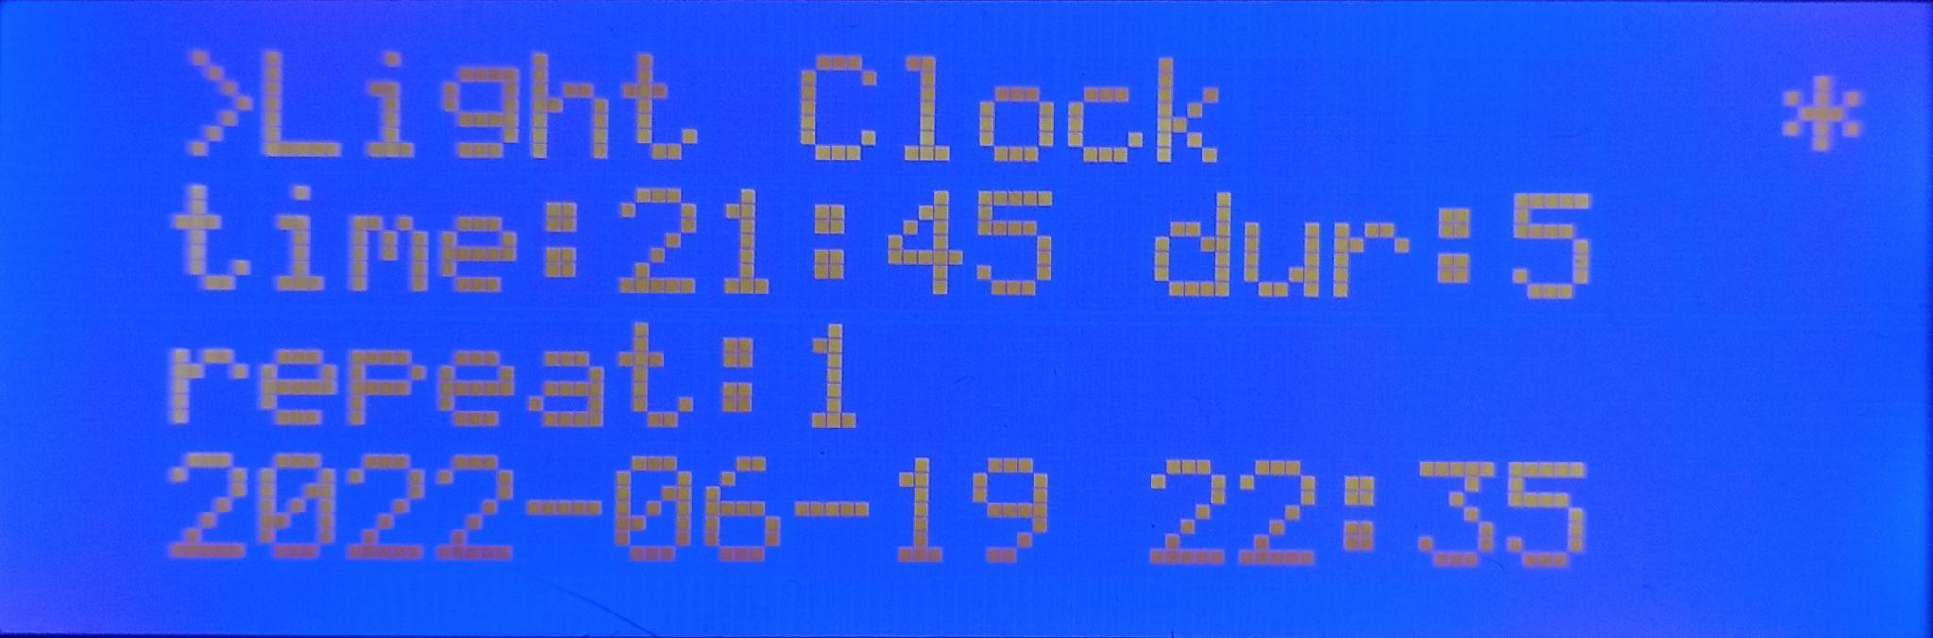

Figure 12. - Example of changes made to the lighting system.

To fix the data already entered by the user, it is necessary to go with the pointer “>” to the header of the corresponding system and press and hold the encoder. The indicator of the establishment of the entered values ​​is the symbol “*”, illustrating that the entered values ​​are set and the system has begun monitoring the system according to these parameters. It is worth noting that it is impossible to set another control mode when monitoring according to another mode within the same system. That is, to set a new mode, it is necessary to remove the current one by pressing and holding the encoder again on the mode header with the symbol “*”. Also, it is impossible to change the values ​​of cells in the mode in which monitoring is already carried out, that is, the symbol “*” is set.

Figure 13 shows the settings menu in manual mode.

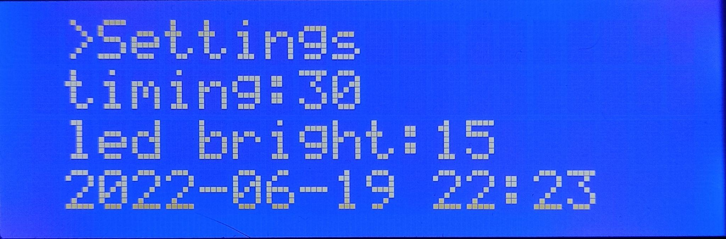

Figure 13. — Settings menu in manual mode.

Below, Figure 14 shows examples of menus for some other systems.

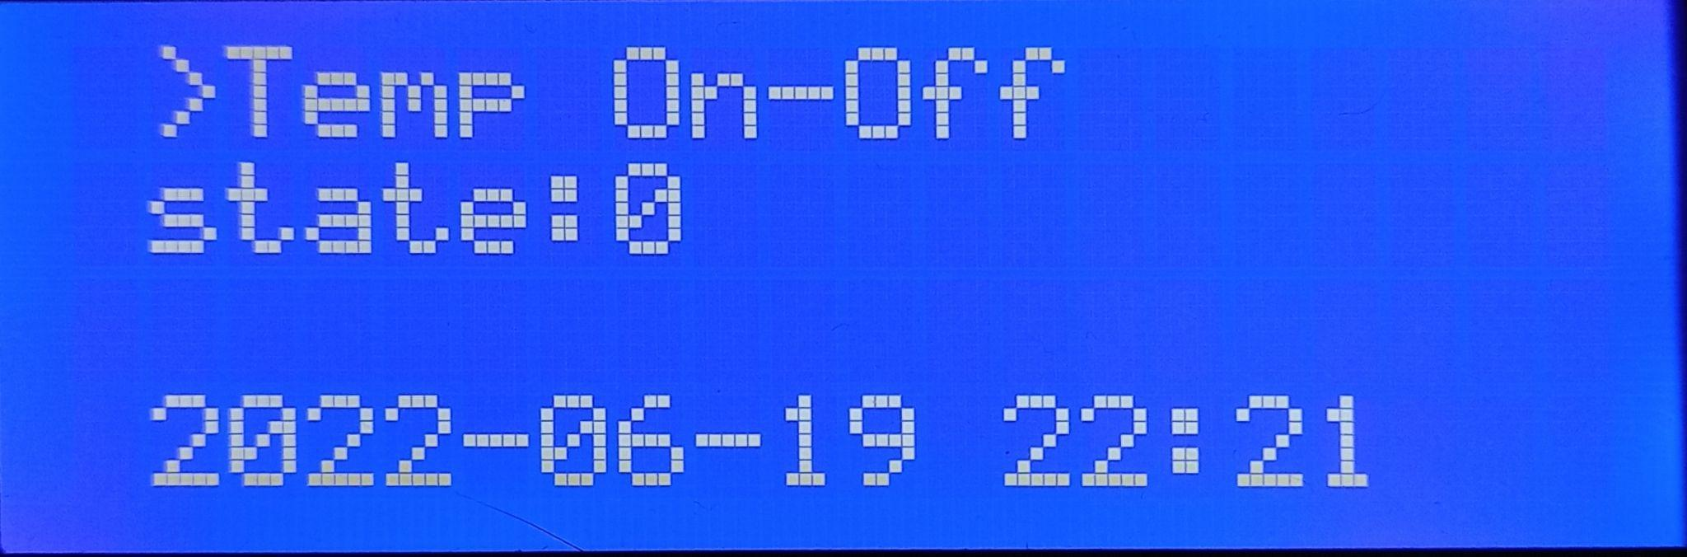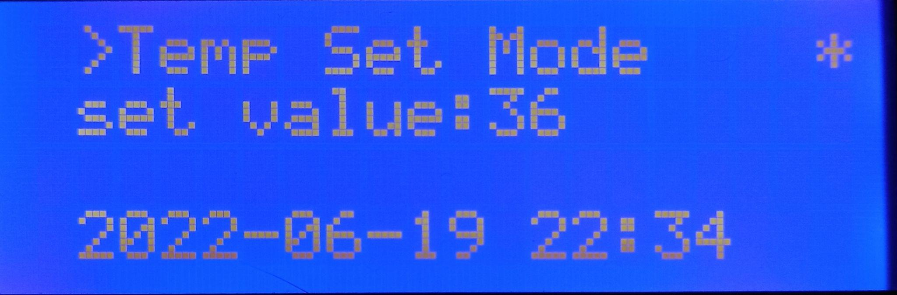

Figure 14. — Examples of other system menus.

**4. Advantages and disadvantages of the device.**

Advantages:

* Ability to connect to multiple access points and/or WiFi networks
* Full communication of online and manual control modes
* Ability to restore mode parameters when power is lost
* Automatic switching between modes when connecting to or finding a WiFi network and/or access point.

Flaws:

* Overflow of the gateway queue (buffer) of the digital serial channel (Serial), which in some cases leads to incorrect data from the sensors. (This drawback is leveled by logical filtering of values. For example, sensor readings cannot be -1 or 0)
* Gradual accumulation of time lag on the DS1302 real time module, which is not observed in online mode, since the system relies on the local network time.

**6. Conclusions**

The developed device is intended for monitoring the main parameters of the phytochamber microclimate system. This system includes web-oriented and manual modes.